**DAILY ONLINE ACTIVITIES SUMMARY**

|  |  |  |  |  |  |  |  |  |
| --- | --- | --- | --- | --- | --- | --- | --- | --- |
| **Date:** | **30/05/2020** | | | | | **Name:** | **Lavanya D M** | |
| **Sem & Sec** | **4th & ‘A’** | | | | | **USN:** | **4AL18CS041** | |
| **Online Test Summary** | | | | | | | | |
| **Subject** | | **Data Communication**  **Maths** | | | | | | |
| **Max. Marks** | | **30**  **30** | | **Score** | | | **24**  **20** | |
| **Certification Course Summary** | | | | | | | | |
| **Course** | **Web page Design for beginners** | | | | | | | |
| **Certificate Provider** | | | **Bitdegree** | | **Duration** | | | **3 days,3hrs** |
| **Coding Challenges** | | | | | | | | |
| **Problem Statement:1)** **Write a C Program to count Uppercase, Lowercase, special character and numeric values for a given String**  **2)Sorting the elements in the circular linked list** | | | | | | | | |
| **Status: complied** | | | | | | | | |
| **Uploaded the report in Github** | | | | | **Yes** | | | |
| **If yes Repository name** | | | | | <https://github.com/lavanyamurthi/lockdown-coding/tree/master> | | | |
| **Uploaded the report in slack** | | | | | **Yes** | | | |

Online Test Details: (Attach the snapshot and briefly write the report for the same)

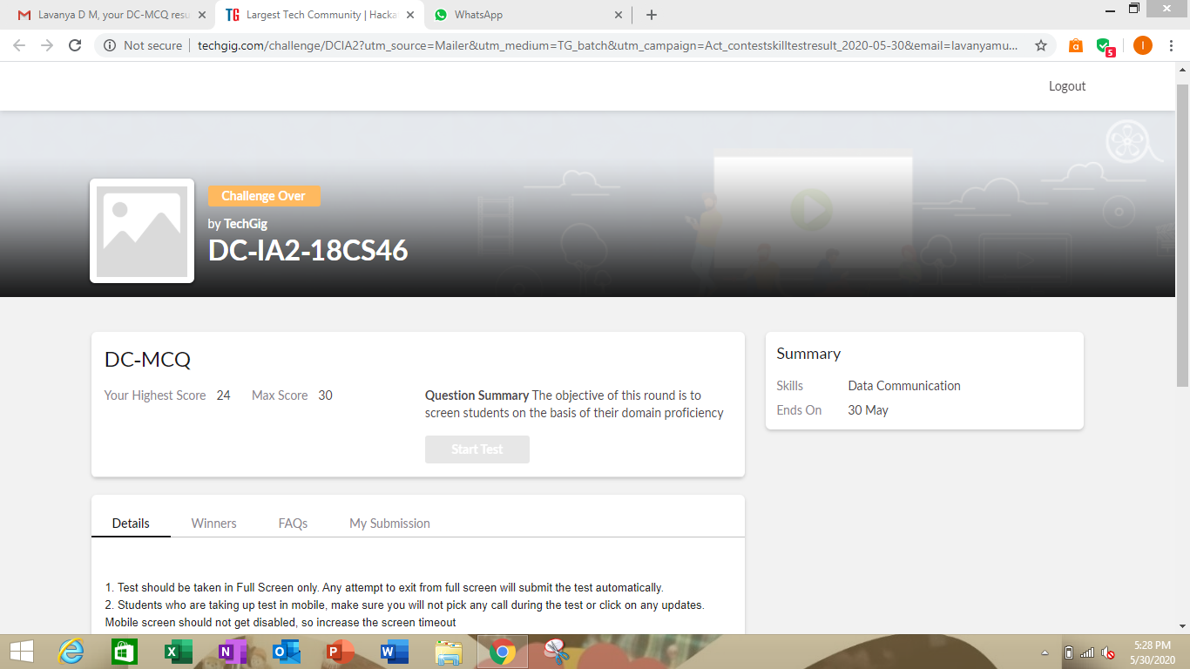

Certification Course Details: (Attach the snapshot and briefly write the report for the same)

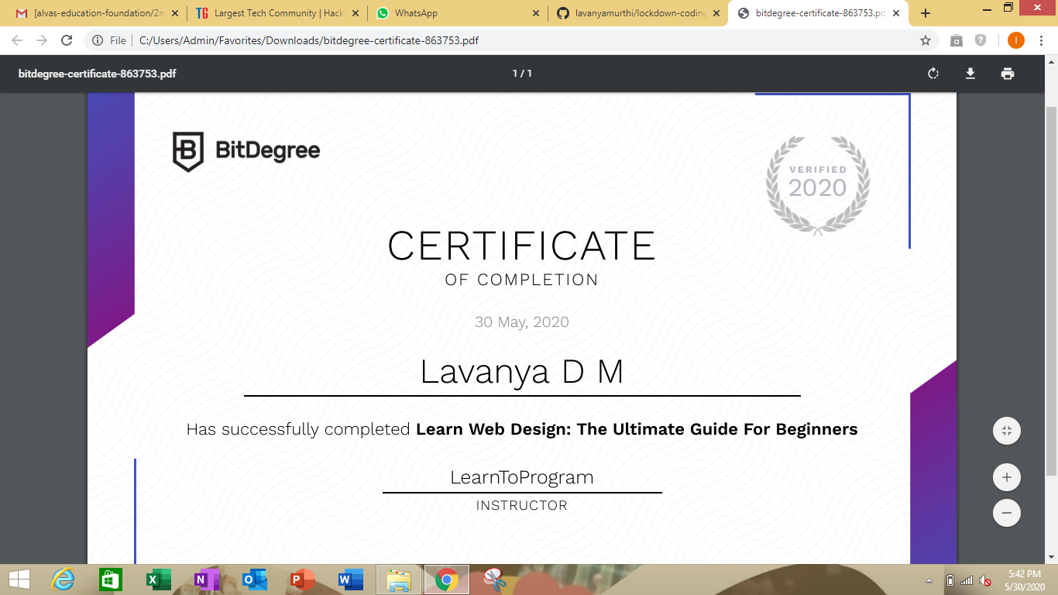

I had successfully completed the Webpage Design for beginners course even I uploaded in gitbub here is the link <https://github.com/lavanyamurthi/lockdown-certificate>

Coding Challenges Details: (Attach the snapshot and briefly write the report for the same)

Problem1:

Write a C Program to count Uppercase, Lowercase, special character and numeric values for a given String  
**nput :** Read a String (combination of character, numeric, special character) from keyboard.  
**Ex: #HaaGs01fOr@haaks07**  
**Output :**  
Upper case letters : 5  
Lower case letters : 8  
Numbers : 4  
Special Characters : 2

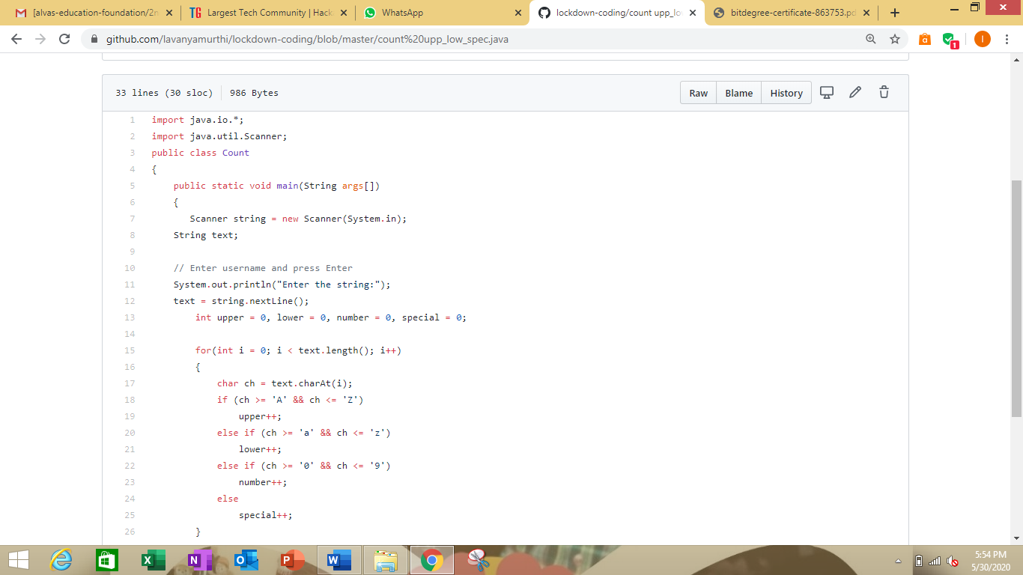

Problem2: Write a java program to sort the elements in the circular link list

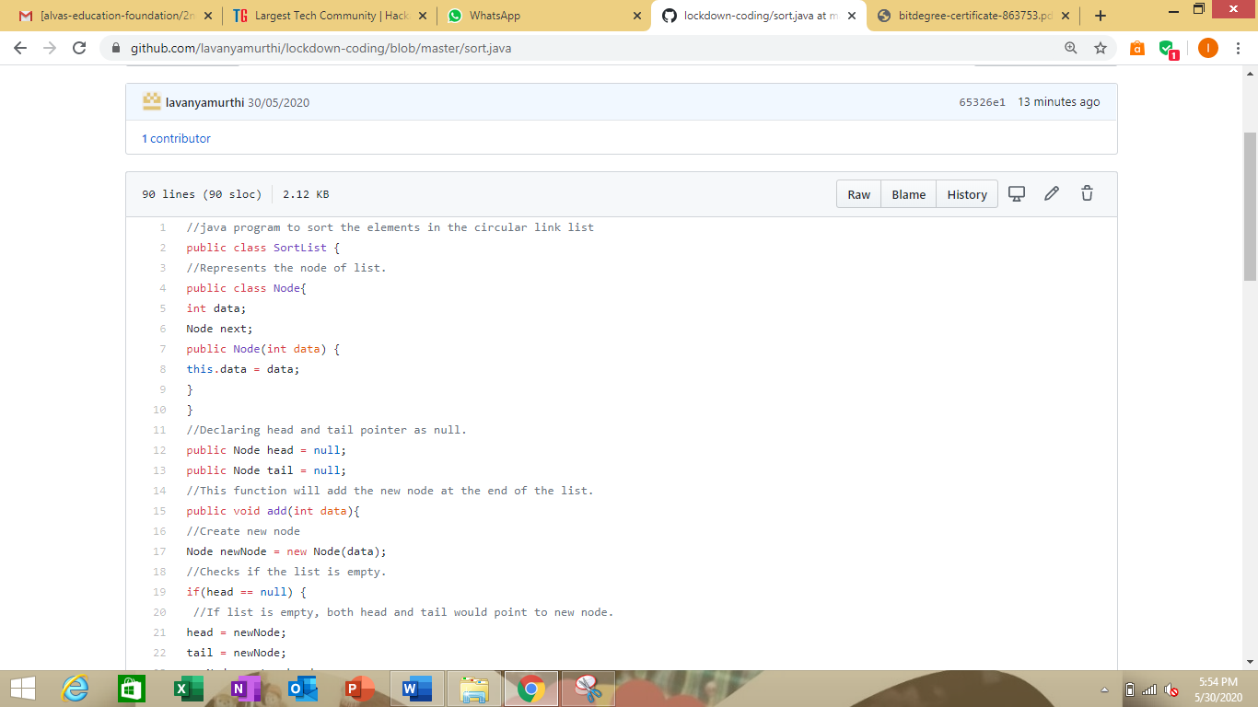

Here I provided the GitHub repository link of coded program

<https://github.com/lavanyamurthi/lockdown-coding/blob/master/count%20upp_low_spec.java>

<https://github.com/lavanyamurthi/lockdown-coding/blob/master/sort.java>